

Media support:

Jill Rick
+1 262-337-0854
jill.rick@global.komatsu

Komatsu introduces new WA700-8 wheel loader
Machine offers enhanced power and efficiency for quarry operations

November 13, 2024 — Komatsu is proud to announce the new WA700-8, a powerful and efficient addition to its range of wheel loaders designed for quarry operations and aggregate producers. This wheel loader is an ideal four-pass match with 70-ton trucks such as Komatsu’s new HD605-10 haul truck. The WA700-8 also offers substantial improvements in performance, efficiency and operator comfort compared to its predecessor, the WA700-3.
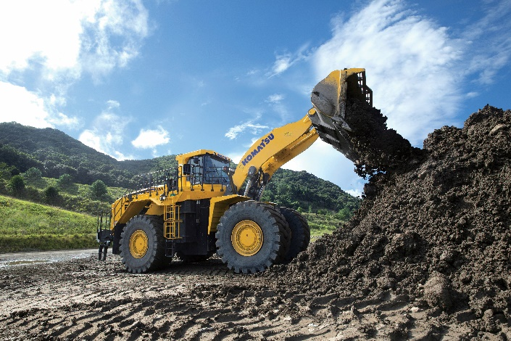
Compared to the previous model, the WA700-8 delivers:
The WA700-8 is Komatsu's newest addition to its lineup of wheel loaders for quarry and aggregate operations.
- Up to 8% more gross power and 15% more torque, making it a robust choice for demanding work environments
- A 6% increase in lifting force and rated load, allowing operators to handle larger volumes of material with greater ease
- Up to 8% more fuel efficiency, helping reduce operating costs while maintaining high productivity

The WA700-8 features a comfortable cabin with technology designed to help reduce operator fatigue on long shifts, including a new advanced joystick steering system and electronic pilot control levers for precision and ease of operation. Automation features such as an automatic digging system, semi-automatic approach, and semi-auto dump systems simplify repetitive tasks, helping operators optimize load cycles. These systems are particularly beneficial for less experienced operators, helping to close skills gaps and enhance overall operational efficiency.
On challenging terrain, the variable traction control system helps prevent tire slippage, prolonging tire life and improving safety in wet or slippery conditions. The loader’s modulated clutch system offers precise control for smooth transitions between forward and reverse, which is critical during truck-loading operations. An available KomVision camera system provides operators with a comprehensive view of the machine’s surroundings, and Komtrax Plus offers remote monitoring and data-driven insights that can help reduce unplanned downtime.
“The new WA700-8 can help quarry operations hit that sweet spot for 70-ton truck loading, making every pass count,” said Sebastian Witkowski, Product Manager. “With a heavier operating weight, greater static tipping load and larger breakout force than the previous model, the WA700-8 is a productive and efficient wheel loader that is ideal for quarry operations.”

About Komatsu
Komatsu develops and supplies technologies, equipment and services for the construction, mining, forklift, industrial and forestry markets. For more than a century, the company has been creating value for its customers through manufacturing and technology innovation, partnering with others to empower a sustainable future where people, business and the planet thrive together. Front-line industries worldwide use Komatsu solutions to develop modern infrastructure, extract fundamental minerals, manage forests and create consumer products. The company's global service and distributor networks support customer operations to help enhance safety and promote productivity while working to optimize performance. Learn more at www.komatsu.com.

# # #

