

Media support:

Jill Rick
+1 262-337-0854
jill.rick@global.komatsu

Komatsu’s new PC365LC-11 excavator takes performance, operator comfort and cost savings to a higher level

December 18, 2025 - Komatsu introduces the new PC365LC-11 multifunction plus excavator to the North American market. It features a refreshed exterior design, an enhanced operator cab, and several new standard and optional features built and optimized for the North American construction market.
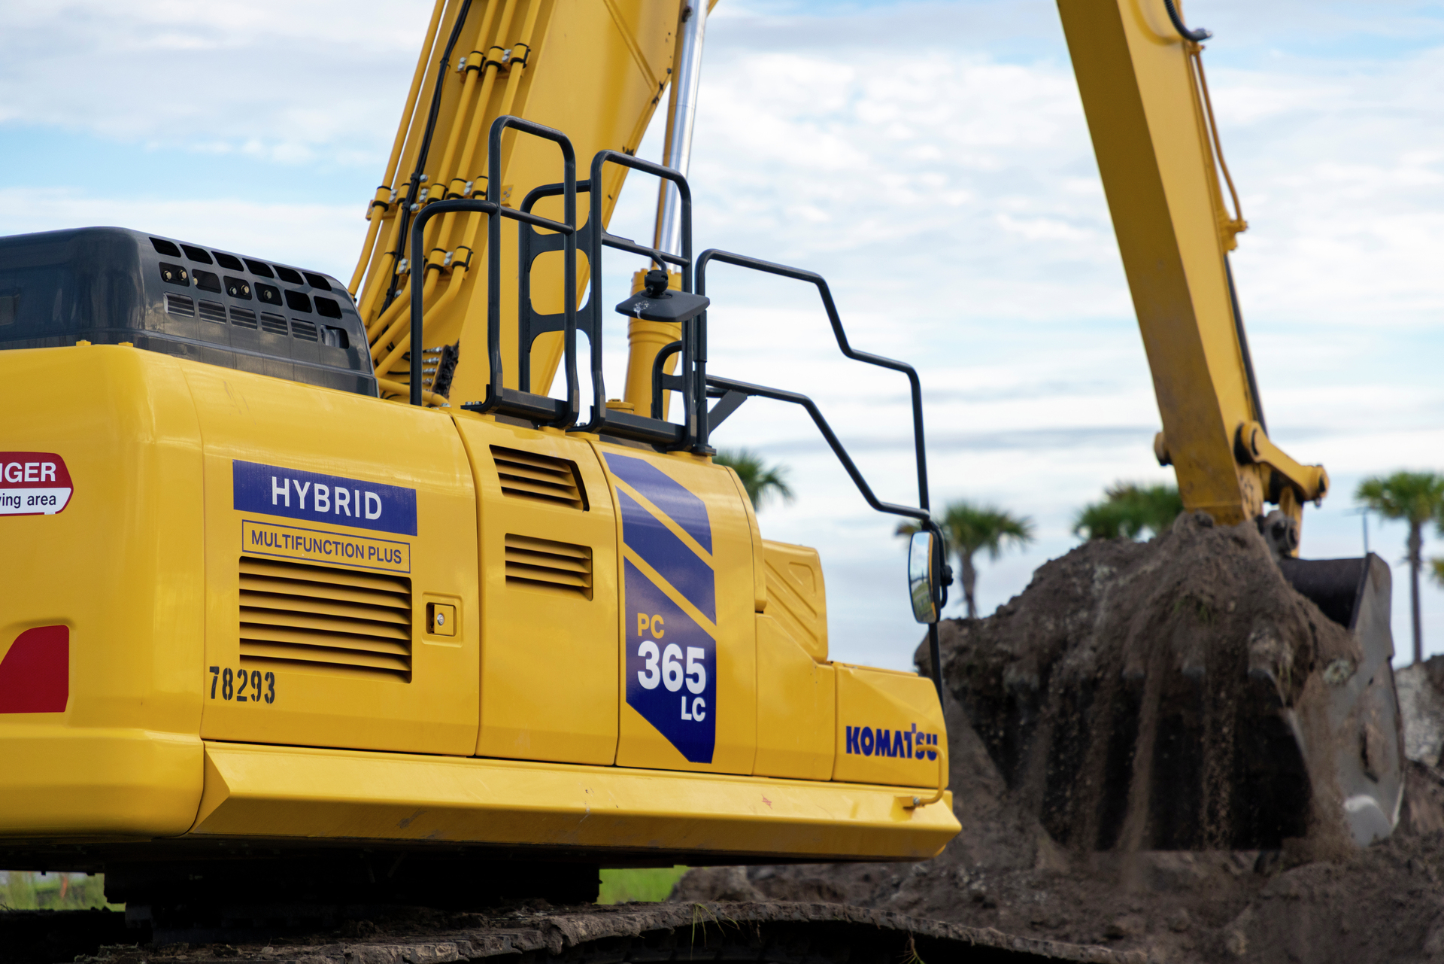
The PC365LC-11 is the only excavator in its class featuring an innovative electric swing system with “boom-up” power assist. The dedicated electric swing motor improves swing speeds and operational efficiency, reducing cycle times in multifunction applications delivering up to a 15% increase in productivity.* The ultracapacitor stores an additional 70 electric horsepower for acceleration when the engine is in ultra-low idle for instantaneous power to the work equipment on demand.
Komatsu's new PC365LC-11 excavator is built to excel in multifunction applications by enhancing productivity, fuel efficiency and operator comfort.
The ultra-low idle state reduces fuel consumption by up to 20%, extending runtimes and lowering total cost of ownership. All electrical energy used in this system is generated during normal operation and stored in the ultracapacitor — no external charging needed. Without the need for hydraulic power for swing operations, this power is fully available for the boom, arm and bucket cylinders. Optimizing hydraulic flow further reduces digging cycle times and reduces work equipment lag, enabling smoother operation in multifunction applications. These features also make the PC365LC-11 significantly quieter.
Compared to the previous model, this workhorse brings new features and enhancements across three key areas: operator experience, technology and attachment flexibility:
- Greater operator comfort for long shifts: A new premium heated air-suspension operator seat features a high leather back, improved cushioning and multiple adjustments. New proportional joysticks offer an intuitive, ergonomic feel that’s easy to use, helping reduce operator fatigue and wrist stress.
- Technology that gets the job done: The KomVision camera system comes as standard** and provides a real-time bird’s-eye view of the machine and its surroundings to help improve situational awareness that drives Komatsu’s mission of zero harm. An optional Smart Construction 3D Machine Guidance kit can be factory-installed. This system provides operators in the field and managers in the office access to 3D design and topography data that help drive work accuracy, control load volumes and promote optimized operations.
- Efficient, fast and versatile attachment operation: The tool control system is standard for machine configurations with an additional hydraulic piping line, which allows operators to configure and store flow rates/target pressures for multiple attachments. Attachment information is displayed on the in-cab monitor interface. This system improves efficiency, precision and performance by enabling quick switching between attachments with accurate, preconfigured hydraulic settings tailored to each tool. Optional hydraulic quick coupler piping can be factory-installed for quick, easy attachment of tools, such as the Lehnhoff quick coupler system.

For added peace of mind, this machine’s electric powertrain components are covered by a 7-year/15,000-hour transferable warranty.
“The PC365LC-11 was engineered for excellence in multifunction applications by leveraging its innovative electric powertrain system to boost jobsite productivity while reducing fuel consumption,” says Matthew Moen, Product Manager. “To highlight these performance enhancements, we’re emphasizing the concept of ‘multifunction plus’ as the defining feature of this machine.”

About Komatsu
Komatsu develops and supplies technologies, equipment and services for the construction, mining, forklift, industrial and forestry markets. For a century, the company has been creating value for its customers through manufacturing and technology innovation, partnering with others to empower a sustainable future where people, business and the planet thrive together. Front-line industries worldwide use Komatsu solutions to develop modern infrastructure, extract fundamental minerals, maintain forests and create consumer products. The company's global service and distributor networks support customer operations, enhancing safety and productivity while optimizing performance. To learn more, visit www.komatsu.com

# # #

*Statistical claims and comparisons referenced herein are made against conventional Komatsu excavators in the same size class, against the Komatsu PC360LC-11 and PC360LCi-11. New features and enhancements referenced herein from the previous model are compared with those of the Komatsu HB365LC-3.

**To be introduced as a running change after model release

