

Media support:

Jill Rick
+1 262-337-0854
jill.rick@global.komatsu

Komatsu offers end-to-end attachment and equipment solutions for high-demand applications and industries

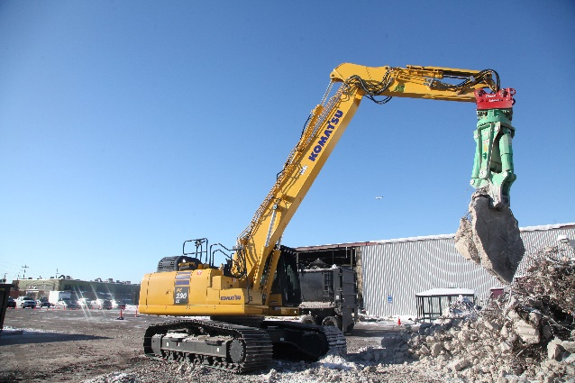
March 3, 2026 – Attachments play a critical role in maximizing equipment investment. From demolition to site development and material handling to waste management, Komatsu offers a streamlined experience for owners and managers to purchase and maintain attachments, along with quality assurances and the backing of an industry stalwart.
The Komatsu attachment lineup on display at CONEXPO-CON/AGG 2026 demonstrates how purpose-built tools can help extend machine versatility, improve efficiency, and support measurable productivity gains across construction, demolition and waste jobsites.
By offering a range of high-quality, reliable attachments, Komatsu provides an integrated solution that helps contractors align machine performance with application requirements.
Attachments like a Lehnhoff fully automatic symmetric quick coupler and the Montabert multiprocessor can help make quick work of demolition tasks.
Featured attachments in Komatsu’s booth include:
- Komatsu universal quick coupler prototype, currently in development, showcased on the PC88MR-11 compact excavator — designed for fast attachment changes with a simple on/off switch sequence, enabling efficient swaps and durable operation of a wide range of rigid and hydraulic attachments
- Komatsu JMHB80H hydraulic breaker engineered for dependable performance and consistent breaking power in demanding conditions
- Komatsu JMHB130H hydraulic breaker with integrated automatic greasing system to help extend service intervals and support uptime
- Komatsu JMHB230V hydraulic breaker featuring fully automatic variable speed technology that adjusts power and striking velocity based on material
- Montabert HCM900 multiprocessor for versatile demolition applications — interchangeable high-strength steel teeth with 360-degree rotation for precise positioning
- Montabert V57 hydraulic breaker with variable-energy technology designed to match striking power and speed to the application
- Lehnhoff SQV series fully automatic symmetric quick couplers designed to significantly reduce attachment change time from inside the cab.
- Hensley buckets — customizable for construction, quarry and mining applications

For breaking applications, Komatsu is highlighting several options engineered to balance power, durability and serviceability. The JMHB80H breaker is designed to deliver consistent performance while minimizing downtime in demanding conditions. The inside is simple and reliable: no tie rods, but with high-quality components, automatic pressure regulation, high back pressure tolerance and blank firing protection. Compatible with Komatsu’s PC88 excavator, it is a compact breaker that’s ideal for utility applications.
The Komatsu JMHB130H breaker is designed to improve efficiency and reduce interruptions to maintenance. An integrated automatic greasing system helps extend service intervals and support consistent performance. Compatible with Komatsu’s PC130LC-11 and PC138USLC-11 excavators, this breaker offers a well-matched solution for midsize breaking applications.
The JMHB230V breaker features fully automatic variable speed technology that adjusts power and striking velocity based on the material being worked. This adaptive control is designed to help optimize breaking efficiency, while advanced blank-firing protection helps reduce unnecessary stress on machine components.
The Montabert HCM900 multiprocessor showcased on the PC490LC-11 demolition excavator is designed to handle a wide range of demolition tasks while reducing the need for frequent attachment changes. Its powerful design and full 360-degree rotation enable operators to position the tool accurately, supporting productivity and control in high-demand demolition environments.
The Montabert V57 hydraulic breaker incorporates variable-energy technology that automatically adjusts striking power and speed to match application requirements for performance across a range of materials. This adaptability makes it a versatile solution for demanding breaking tasks.
Efficiency in attachment changes remains a key focus for contractors seeking to reduce idle time. The Lehnhoff SQV series range of automatic quick couplers is designed to significantly reduce change time by allowing operators to switch attachments hydraulically from inside the cab. Eliminating manual intervention during changeovers can improve jobsite efficiency and support safer operating practices.
In addition to breakers and couplers, Hensley buckets on display are designed to enhance excavator and wheel loader productivity in construction, quarry and mining applications. These buckets can be customized for a range of load sizes and material types to align with specific project requirements.
“Contractors need tools that adapt as quickly as their jobsites change,” said Aaron Scarfia, Director, Product and Services, Attachments. “By engineering attachments that are durable, efficient and easy to integrate, we are helping crews expand machine capability and maintain consistent performance throughout the workday.”
About Komatsu
Komatsu develops and supplies technologies, equipment and services for the construction, mining, forklift, industrial and forestry markets. For a century, the company has been creating value for its customers through manufacturing and technology innovation, partnering with others to empower a sustainable future where people, business and the planet thrive together. Front-line industries worldwide use Komatsu solutions to develop modern infrastructure, extract fundamental minerals, maintain forests and create consumer products. The company's global service and distributor networks support customer operations, enhancing safety and productivity while optimizing performance. To learn more, visit www.komatsu.com

# # #

