

Media support:

Jill Rick
+1 262-337-0854
jill.rick@global.komatsu

Smart Quarry Autonomous finalist for industry award; expands quarry-specific digital offerings

Solution delivers simple, cost-effective autonomous haulage for open-pit quarries

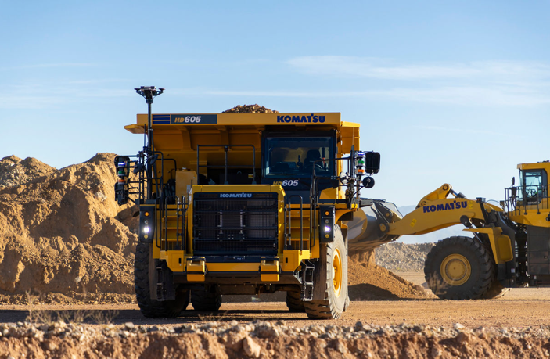
March 3, 2026 — Komatsu Smart Quarry Autonomous, powered by Pronto, has been named a finalist for the CONEXPO-CON/AGG Next Level Awards, which recognize equipment and technologies that demonstrate measurable potential to advance operations. The technology awards highlight solutions that apply emerging automation and digital capabilities to real-world jobsite challenges, with the winner determined by votes cast during the show March 3-7. It is part of Komatsu North America’s expanding technology offering for quarry aggregate operations.
Komatsu HD605-10 truck fitted with Smart Quarry Autonomous and Smart Quarry Site solutions
Komatsu, a global leader in mining and construction equipment, aims to make hard work easier by digitally transforming quarry aggregate operations through its Smart Quarry suite of solutions, including Smart Quarry Site.
Komatsu HD605-10 truck fitted with Smart Quarry Autonomous
“Quarry operations are under pressure to keep production moving despite ongoing labor challenges,” said Michael Gidaspow, Chief Digital Officer, Komatsu North America. “Autonomous haulage can help address ongoing workforce challenges by reducing reliance on skilled operators, helping to mitigate the impact of absenteeism and shift changes and enabling more predictable haul cycles across operating hours. Being recognized as a Next Level Award finalist reinforces that quarry-scale autonomy can deliver meaningful operational wins without unnecessary complexity.”
Smart Quarry Autonomous is designed to be deployed quickly and economically without the need for extensive site infrastructure or a dedicated control center. The solution can be installed as a retrofit on select Komatsu haul trucks enabling quarry operators to adopt autonomy in stages, matching the sensor stack to the specific complexity of their haul roads and environment.
The autonomous system utilizes artificial intelligence, onboard computing and sensor-based perception technologies to navigate mapped haul routes with minimal setup. System configurations are determined based on site requirements and applicable commercial agreements.
Komatsu’s dealers support Smart Quarry Autonomous through hardware installation, system deployment, training and ongoing service. Components are supplied through Komatsu’s distribution network, helping ensure consistency, supportability and long-term service readiness.
Komatsu North America and Pronto, the Silicon Valley-based off-road autonomy pioneer, announced in August 2025 a commercial partnership focused on providing a practical and scalable path to autonomy for open-pit quarries and aggregate producers in North America.
About Komatsu
Komatsu develops and supplies technologies, equipment and services for the construction, mining, forklift, industrial and forestry markets. For more than a century, the company has been creating value for its customers through manufacturing and technology innovation, partnering with others to empower a sustainable future where people, business and the planet thrive together. Front-line industries worldwide use Komatsu solutions to develop modern infrastructure, extract fundamental minerals, manage forests and create consumer products. The company's service and distributor networks support customer operations to help enhance safety and promote productivity while working to optimize performance.

Learn more at www.komatsu.com.
# # #

