

Media support:

Jill Rick
+1 262-337-0854
jill.rick@global.komatsu

Komatsu Smart Construction makes stronger connection between machines, office, work
New hardware and software make capturing and using site data easier

March 3, 2026 — At CONEXPO-CON/AGG 2026, Komatsu will demonstrate how its Smart Construction digital solutions make hard construction work easier, highlighted by several major new hardware and software launches. Smart Construction solutions connect machines and the office, enabling contractors to track progress, visualize work in three dimensions, support precise earthmoving to design, and work with both Komatsu machines and mixed fleets.
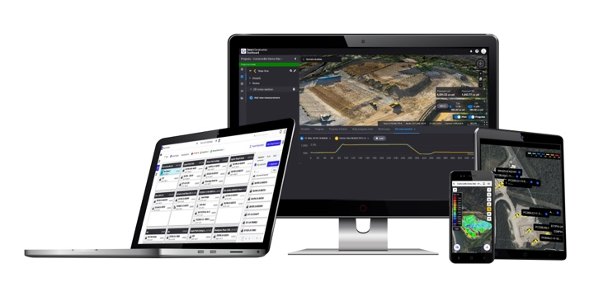
At the center of the ecosystem is Smart Construction Dashboard, a cloud-based platform that creates a 3D virtual twin of the jobsite using design files, drone data and machine as-built information. This centralized view supports more informed planning, progress tracking and reporting throughout the life of a project. As-built data from machines equipped with intelligent machine control (IMC) and Smart Construction 3D Machine Guidance can be imported with minimal effort.
Smart Construction solutions
Komatsu is also extending access to the software’s insights with the introduction of Smart Construction Dashboard Mobile, a companion app that brings key project information out of the office. Users can view cut-and-fill and stockpile volumes, as well as perform in-field line and area measurements.
Two new hardware solutions are designed to further simplify and accelerate site data capture:
Smart Construction 3D Machine Guidance Flex adds as-built data capture to nearly any vehicle, especially supervisor trucks, scrapers and wheel loaders. The system also provides guidance by displaying current position against final design on an in-cab tablet, especially helpful supporting scraper and loader operations. Dealer installation typically takes only a few hours.
Smart Construction Edge is an RTK base station that can process drone data directly on the device. In some conditions, it’s possible to use the data in Smart Construction Dashboard before leaving the site. On sites smaller than 50 acres, Smart Construction Edge eliminates the need for ground control points.
“There is real value in having current, reliable terrain and production data from your jobsite,” said Jason Anetsberger, Senior Director, Customer Solutions. “Knowing what was completed today helps teams plan tomorrow, communicate clearly with clients and make better decisions. Our focus is on making that information easier and faster to collect and use.”
To simplify access to core applications that support machines equipped with intelligent machine control or Smart Construction 3D Machine Guidance, Komatsu is offering the Smart Construction Advantage package. The package includes Smart Construction Dashboard for site visualization, Smart Construction Remote for remote operator support and design file transfer, and Smart Construction Fleet Lite for basic payload tracking. The package price is significantly lower than buying each application separately and includes two applications available only with the bundle:
Smart Construction Whiteboard, a digital dispatch tool modeled after traditional office whiteboards, allows users to drag-and-drop machines and labor onto jobsite columns. Assignments are visible to both office and field teams to support utilization and communication.
Smart Construction Home serves as a homepage for projects, displaying jobsites on a map with key metrics such as job completion percentage. Each project can be opened directly in Smart Construction Dashboard with a single click.
Additional Smart Construction solutions include:
Smart Construction 3D Machine Guidance, which adds GPS guidance and as-built capture to excavators of any brand
Smart Construction Remote, which enables wireless design file transfer and remote telematics viewing
Smart Construction Design, a service that creates 3D design files optimized for machine control
Smart Construction Field, a web and smartphone application for tracking field activities such as timecards, materials, fuel and machine inspections.
Smart Construction Office, project management software designed for construction operations with proactive intelligence troubleshooting plus APIs to many back-office applications.
Complementary hardware, including drones, aeropoints and base/rover systems
Through Smart Construction, Komatsu continues to expand how digital tools support jobsite predictability, collaboration and decision-making across the construction lifecycle.

About Komatsu
Komatsu develops and supplies technologies, equipment and services for the construction, mining, forklift, industrial and forestry markets. For more than a century, the company has been creating value for its customers through manufacturing and technology innovation, partnering with others to empower a sustainable future where people, business and the planet thrive together. Front-line industries worldwide use Komatsu solutions to develop modern infrastructure, extract fundamental minerals, manage forests and create consumer products. The company's global service and distributor networks support customer operations to help enhance safety and promote productivity while working to optimize performance. Learn more at www.komatsu.com.

# # #

