

Media support:

Jill Rick
+1 262-337-0854
jill.rick@global.komatsu

Komatsu to introduce the PC158USLC-12 and PC158USLCi-12 tight tail swing excavators later in 2026
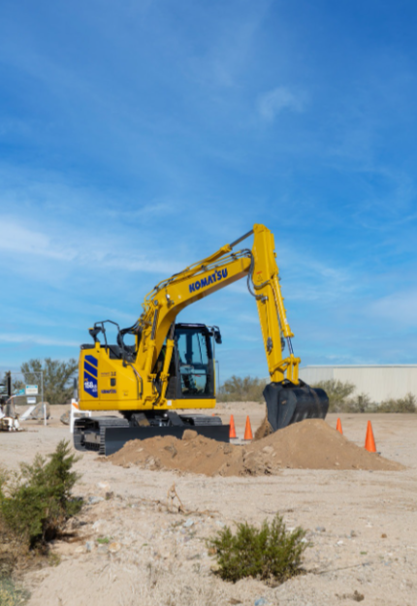
March 3, 2026 — Komatsu plans to introduce the PC158USLC-12 and PC158USLCi-12 excavators later this year (2026), expanding its next-generation -12 excavator lineup with a compact, tight tail-swing model designed for efficiency and an enhanced operator environment. These excavators build on the legacy of Komatsu’s PC138USLC-11, and the PC158USLCi-12 will be Komatsu’s first tight-tail excavator with the latest factory-integrated machine control, IMC 3.0.
The design of the PC158USLC-12 and PC158USLCi-12 is tailored to the North American market, with an emphasis on enhancing productivity, increasing lift capacity and improving hydraulic attachment flow while reducing fuel consumption — all within a footprint that is easily transportable from site to site.
Designed for contractors working in space-constrained jobsites — such as urban construction, utilities and roadwork — these excavators are built to help operators work more confidently while maintaining control over grade, boundary restrictions and attachment performance. They reflect Komatsu’s continued focus on integrating technology and an operator-centered design to improve productivity and address workforce challenges.
The PC158USLCi-12, featuring IMC 3.0, will make its first appearance at CONEXPO-CON/AGG 2026. IMC 3.0 introduces several advanced features new to this size class to enhance productivity, working accuracy and jobsite safety.
The PC158USLCi-12 features a potent combination of an operator-focused cab and the latest IMC 3.0 technology.
Key features of both excavators include:
- New electric hydraulic control system improves operability by providing the ability to customize work equipment speeds, joystick response and combined operation balance to meet the preferences of each operator
- Newly designed wide-profile cab improves visibility and provides a more spacious, comfortable working environment; features a new multi-function seat, EPC joysticks, and an intuitive 8” touchscreen monitor to maximize operator comfort during long working shifts
- Komvision 360° monitoring system with human and object and human detection that can increase operator awareness and mitigate the risk of accidental collision during operation with auto-stop control
- Additional standard features include 2D machine control, 2D boundary control, a bucket payload monitoring system and joystick travel to boost jobsite efficiency

Key features exclusive to the PC158USLCi-12 excavator include:
- Addition of a high-definition 10.1” ICT monitor with intuitive, user-friendly operation
- 3D machine control semi-autonomously guides movements in real time, enabling precise excavation across complex terrains
- 3D boundary control allows the operator to set multiple work-restriction surfaces with specific boundaries; once defined, these settings remain unchanged even when the machine travels and changes elevation, making it able to compensate for location and elevation changes on the jobsite
- Swing-to-line and travel-along-line functions work in tandem to improve productivity while reducing operator error to maximize efficiency in applications such as trenching
- Additional IMC 3.0 features include in-field design, simple measurements attachment calibration, auto swing and an enhanced payload monitoring system
The PC158USLCi-12 brings together significant key excavator specification improvements, a redesigned cab and Komatsu’s proprietary IMC 3.0 technology to offer a comprehensive solution for contractors working in confined areas.
“What we heard consistently from operators, fleet managers and business owners was the need for a tight tail swing excavator that delivers advanced automation without adding complexity for the operator,” said Matt Moen, Product Manager, Excavators, Komatsu. “The PC158USLCi-12 was developed to help operators stay in control of the work while benefiting from sophisticated IMC 3.0 features that are easy for operators to use. This machine is designed to help drive accuracy, efficiency and productivity on the jobsite.”
The PC158USLC-12 and PC158USLCi-12 excavators are scheduled to launch later in 2026. Additional details, including availability and full specifications, will be released closer to the launch date.
About Komatsu
Komatsu develops and supplies technologies, equipment and services for the construction, mining, forklift, industrial and forestry markets. For a century, the company has been creating value for its customers through manufacturing and technology innovation, partnering with others to empower a sustainable future where people, business and the planet thrive together. Front-line industries worldwide use Komatsu solutions to develop modern infrastructure, extract fundamental minerals, maintain forests and create consumer products. The company's global service and distributor networks support customer operations, enhancing safety and productivity while optimizing performance. To learn more, visit www.komatsu.com

# # #

*All comparisons are to the prior Komatsu model unless otherwise specifically stated.

