

Media support:

Jill Rick
+1 262-337-0854
jill.rick@global.komatsu

Komatsu highlights continued North American manufacturing and service investments at CONEXPO-CON/AGG 2026

March 3, 2026 — Komatsu is reinforcing its long-term commitment to North America through sustained investments in manufacturing, service and remanufacturing capabilities. At CONEXPO-CON/AGG 2026, the company will share how facility expansions, infrastructure modernization and strategic acquisitions are strengthening localized production and support for construction and forestry customers.
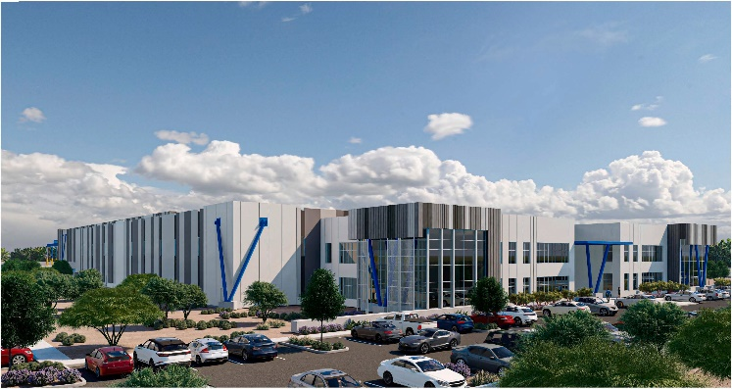
“Customers today are managing tighter schedules, higher utilization rates and greater supply chain complexity than ever before,” said Rod Bull, CEO, Komatsu North America. “To better serve them, we are positioning parts, service expertise and rebuild capability nearer more jobsites, so they can gain more control over uptime, planning and costs. That proximity matters to their success.”
Komatsu's new Mesa, Arizona, service and support center is scheduled to open later this year.
Over the past 10 years, Komatsu has invested more than $5 billion in the North American manufacturing industry by adding companies to the Komatsu group. The company has invested more than $650 million in North American infrastructure to modernize facilities and strengthen operational capabilities. Globally, Komatsu’s fiscal year 2024 research and development investment totaled $725 million, with a significant portion supporting North American engineering initiatives focused on automation, artificial intelligence and digital jobsite optimization.
Recent investments include:
- Construction of a new 215,000-square-foot mining sales and service facility in Mesa, Arizona, representing an $80 million investment and tripling Komatsu’s current footprint in the region
- Expansion of the Edmonton, Alberta, operation into a 135,000-square-foot full-service parts distribution center, doubling warehouse capacity to enhance delivery capabilities across Canada
- The recent acquisition of remanufacturing specialist SRC of Lexington, Inc., to expand capabilities in the United States and meet growing demand for remanufactured components
The new Mesa facility, scheduled for completion later in 2026, will enhance service capacity for mining customers, particularly in the Southwestern United States, and support up to 100 new long-term positions within the first few years of operation.
In Canada, the Edmonton parts distribution center is set to open in early 2026 and will transition from a regional depot to a fully integrated hub within Komatsu’s North American logistics network. By expanding inventory capacity and system integration, the facility is designed to reduce lead times and improve parts availability for dealers and customers across western Canada.
The acquisition of SRC of Lexington further strengthens Komatsu’s lifecycle support strategy. Demand for remanufactured components has increased alongside growth in the installed base of quarry and mining equipment in North America, with Komatsu’s reman transaction volume increasing approximately fourfold from fiscal year 2010 to fiscal year 2024. Expanding remanufacturing capabilities in the United States is intended to improve responsiveness while supporting resource efficiency through component reuse.
About Komatsu
Komatsu develops and supplies technologies, equipment and services for the construction, mining, forklift, industrial and forestry markets. For more than a century, the company has been creating value for its customers through manufacturing and technology innovation, partnering with others to empower a sustainable future where people, business and the planet thrive together. Front-line industries worldwide use Komatsu solutions to develop modern infrastructure, extract fundamental minerals, manage forests and create consumer products. The company's global service and distributor networks support customer operations to help enhance safety and promote productivity while working to optimize performance. Learn more at www.komatsu.com.

# # #

