

Media support:

Jill Rick
+1 262-337-0854
jill.rick@global.komatsu

Komatsu pushes into CONEXPO-CON/AGG 2026 with an exclusive first look at two next-generation dozers
March 3, 2026 — Komatsu is offering CONEXPO-CON/AGG 2026 show attendees an exclusive preview of two next-generation crawler dozers engineered to advance productivity and efficiency in earthmoving applications from site development and road construction to mining. The D61PXi-25 dozer with intelligent machine control (IMC 3.0) and the D175AX-10 large production dozer represent the next phase in Komatsu’s evolution of powertrain performance, operator-centered design and integrated technology.
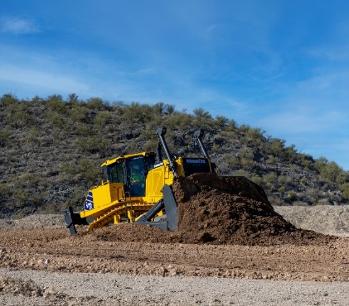
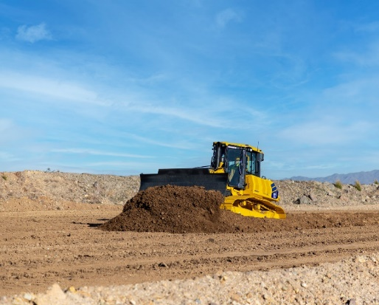
From precision grading to large-scale earthmoving and haul road maintenance, contractors are navigating tighter margins, skilled labor shortages and increasing pressure to move material efficiently. The D61PXi-25 and D175AX-10 are engineered to address these demands and to deliver measurable gains in productivity, fuel efficiency and controllability.
The D61PXi-25 with IMC 3.0 and the D175AX-10 large production dozer represent the next phase in Komatsu’s crawler dozer lineup.
D61PXi-25: IMC 3.0 in the midsize class
The D61PXi-25 is a fully redesigned IMC dozer built to deliver force, precision and efficiency in a size class widely in demand throughout North America. Compared to the D61PXi-24, it offers up to 10% greater productivity and up to 10% greater fuel efficiency, along with an 18% increase in blade capacity and up to 20% more steering power.
Key features include:
- IMC 3.0 with new 10-inch intelligent control touchscreen and updated user interface
- Auto steering designed to support consistent operation and reduce operator effort
- IMC operation helps maintain functionality if the GNSS signal is temporarily lost
- Redesigned cab — enhanced visibility, ergonomic joysticks and centralized controls
With an advanced electronically controlled high-pressure supply and EGR-less engine design, the D61PXi-25 is engineered to help increase material moved per gallon while supporting precise grading performance. The new cab environment is designed to help operators maintain focus and comfort through long shifts, with enhanced visibility and customizable control settings.

D175AX-10: Next-generation performance in the large dozer class
The D175AX-10 represents the first of Komatsu’s next-generation -10 large production dozers. As the successor to the D155AX-8, it introduces a new main frame, track frames, powertrain, cab and blade system — all designed to help deliver high production and control total cost of ownership in demanding applications.
Compared to the D155AX-8, the D175AX-10 provides up to:
- 26% more horsepower, with 450 HP (336 kW)
- 25% increase in cubic yards of material moved per hour
- 15% enhancement in fuel efficiency (measured in cubic yards moved per gallon of fuel consumed)
- 35% tighter turning radius
This new dozer also features a new 4-speed automatic transmission and a redesigned semi-U blade designed for enhanced penetration and reduced material resistance. The next-generation cab delivers comfort and efficiency with exceptional ride comfort, KomVision 360° visibility system and user-friendly touchscreen monitor.
The new steering system enables pivot, power and spin turns without sacrificing blade load, enhancing maneuverability in side-cutting and scraper-push applications. An eight-roller track frame and updated undercarriage configurations are engineered to deliver durability and ride quality in heavy production environments.
The D175AX-10 also features Komatsu’s newest offroad engine, the DBA127 EGR-less engine. This engine helps produce more power for stronger penetration and is designed to lower TCO by being more fuel-efficient and extending service intervals (reducing downtime).
“The contractors and mining operations we work with are asking for measurable performance gains without sacrificing operator comfort or long-term durability,” said Paul Moore, Vice President for Products, Marketing and Service. “With the D61PXi-25 and the D175AX-10, we focused on integrating higher output, more efficient powertrains and advanced control systems that help move more material per pass while supporting operators in the cab.”
Both models are designed to integrate with Komatsu’s broader digital and lifecycle support solutions. The D61PXi-25 incorporates IMC 3.0 technology, and both dozers are supported by Smart Construction solutions, Komatsu Care programs, Komatsu Genuine Parts and other service offerings designed to optimize uptime and long-term value.
The D175AX-10 is currently targeted for introduction in North America in 2026. The D61PXi-25 is planned for a later launch timeframe. Timing and availability are subject to change and will be fully announced at a later date.
About Komatsu
Komatsu develops and supplies technologies, equipment and services for the construction, mining, forklift, industrial and forestry markets. For a century, the company has been creating value for its customers through manufacturing and technology innovation, partnering with others to empower a sustainable future where people, business and the planet thrive together. Front-line industries worldwide use Komatsu solutions to develop modern infrastructure, extract fundamental minerals, maintain forests and create consumer products. The company's global service and distributor networks support customer operations, enhancing safety and productivity while optimizing performance. To learn more, visit www.komatsu.com
# # #

*All comparisons are to the prior Komatsu D155AX-8 model unless otherwise specifically stated.

