

Media support:

Jill Rick
+1 262-337-0854
jill.rick@global.komatsu

Komatsu introduces WA485-11 and WA475-11 wheel loaders
New machines built for increased productivity, operator comfort and maintenance ease

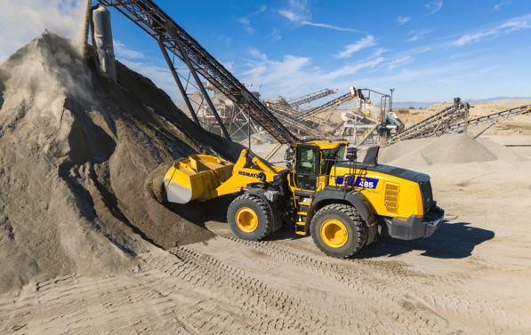
March 11, 2025 — Komatsu is excited to introduce the new WA475-11 and WA485-11 wheel loader models. These versatile machines are designed to move material efficiently and effectively, increasing productivity while also providing improved operator comfort and maintenance ease. Sharp focus has been put on reducing customers’ total cost of ownership (TCO).
The WA485-11 offers up to 12 percent lower fuel consumption, 21 percent more engine power and 13 percent faster climbing speed compared to its predecessor, the WA480-8. The WA475-11 provides up to 7 percent lower fuel consumption, 18 percent higher engine power and 40 percent greater climbing speed compared to the WA475-10.
Komatsu's new WA485-11 offers a range of new productivity and efficiency features
Both loaders now include Komatsu Hydrostatic-Mechanical Transmission (KHMT), equipped with improved fuel efficiency and productivity. Operators will appreciate the large comfortable four-pillar cab, angle feedback joystick steering and independent work control to help reduce fatigue on long operating days. The new wheel loaders also feature standard rear object detection to promote enhanced jobsite safety and deluxe LED light package.
“In designing the WA475-11 and WA485-11, we focused on what truly matters to our customers based on years of direct customer feedback – efficiency, power, safety and operator comfort. These wheel loaders build on proven performance of previous models with innovative advancements designed to enhance productivity,” said Bruce Boebel, Director of Products and Service at Komatsu. “We’re excited to introduce these machines and put them to use for our aggregate customers and beyond.”
Both models offer yard loader configurations that include additional stability features such as a larger bucket, wide low-profile tires, and additional counterweight designed to support higher productivity in aggregate applications.
For more information, contact a Komatsu distributor or visit komatsu.com.

About Komatsu
Komatsu develops and supplies technologies, equipment and services for the construction, mining, forklift, industrial and forestry markets. For more than a century, the company has been creating value for its customers through manufacturing and technology innovation, partnering with others to empower a sustainable future where people, business and the planet thrive together. Front-line industries worldwide use Komatsu solutions to develop modern infrastructure, extract fundamental minerals, manage forests and create consumer products. The company's global service and distributor networks support customer operations to help enhance safety and promote productivity while working to optimize performance. Learn more at www.komatsu.com.

# # #

