

My Komatsu

*Media fact sheet*

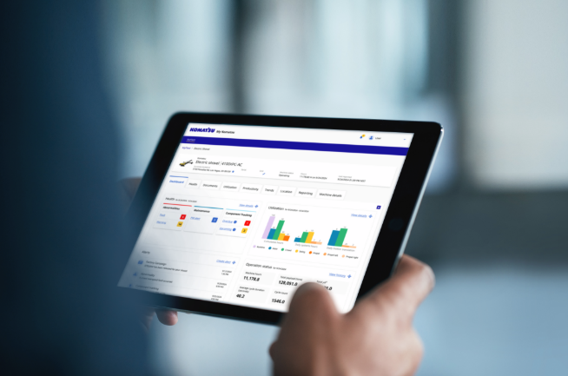My Komatsu is a comprehensive digital hub that allows 24/7 access to machine telematics data, parts manuals, service manuals, software and parts ordering — all in a single place.

My Komatsu is a comprehensive solution that provides an array of insightful information about your fleet.

My Komatsu is designed to help customers harness cutting-edge technology to manage their fleet. Users can connect 24/7 to their machine data and support materials from anywhere, so they can manage their fleet with digital tools to help them be effective and economical.

My Komatsu users gain instant access to parts and service information through a single, comprehensive portal that makes it easy to order parts online. Customers on this digital platform can visualize and evaluate their assets with fleet-wide or equipment-specific information — on any device.

**The My Komatsu suite of solutions focuses on four mission-critical areas:**

* Fleet management (telematics)
* Service support
* Machine operations
* Parts support