

Lehnhoff SQ-V quick coupler
Media fact sheet

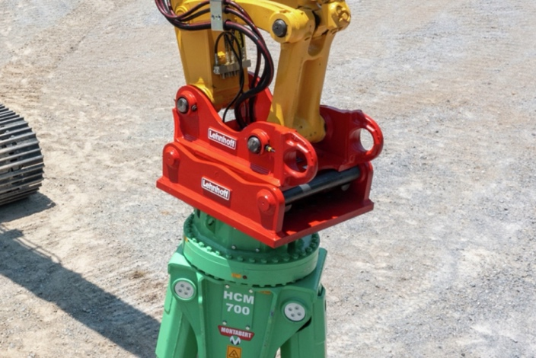
The Lehnhoff SQ-V is a fully automatic, symmetric quick coupler system enabling operators to change rigid and hydraulic attachments without leaving the cab, enhancing safety and productivity. Its symmetric design and patented valve technology facilitate seamless attachment changes, reducing downtime during short working cycles. This system also helps optimize operations’ range of services by supporting various attachments in both backhoe and shovel modes.
Operators can change attachments without leaving the cab with the Lehnhoff SQ-V quick coupler

Its advanced valve technology helps ensure precise hydraulic connections with minimal pressure loss and low heat generation. Additionally, the system's robust construction and integrated depressurization unit help improve durability and reduce maintenance costs, making it an efficient solution for construction, demolition, and land development projects.

Key features
- Fully automatic operation that enables attachment changes without leaving the cab
- Symmetric design for 180-degree application of attachments
- Patented valve technology for precise hydraulic connections
- Integrated depressurization unit to extend valve service life
- Reinforced S (stick side) and A (attachment side) blocks for enhanced durability

Quick specs
- Excavator class: 17,640-154,325 lbs. (8-70 mt)
- Pick-up shaft diameter: 2.36 in (60 mm), 2.76 in. (70 mm), 3.15 in. (80 mm) or 3.54 in. (90 mm)
- Approximate weight: 375-1,631 lbs.

