**WA485-11 wheel loader with waste configuration option**

*Media fact sheet*

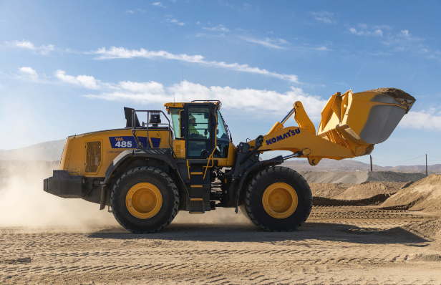The Komatsu WA485-11 is a new wheel loader with advanced features designed to enhance productivity, help control fuel consumption, and make maintenance easier (when compared to the previous model). With a newly developed, fuel-efficient Komatsu DBA127 engine, a Komatsu Hydraulic Mechanical Transmission (KHMT) engineered to deliver excellent controllability and high transmission efficiency, and a new cab with operator-assistance features like Angle Feedback Joystick Steering (AFJS) controls, it’s designed to be an ideal wheel loader for quarry operations.

The WA485-11is available in a purpose-built configuration for waste applications that addresses the unique challenges and hazards of landfills and recycling or transfer facilities.

The addition of the proprietary Komatsu Hydraulic Mechanical Transmission to the WA485-11YL is notable, giving this workhorse an advanced design engineered to enhance productivity and efficiency of material loading cycles. Plus, the KHMT's control system comprehensively assesses the work situation and works to control power distribution, synchronizing low fuel consumption at low engine speed and delivering exceptional acceleration performance.

The new WA485-11 is available in a waste configuration. This purpose-built package of waste application features includes additional guarding and shielding that help protect key machine areas and the operator, as well as more robust cab filtration. The waste configuration also includes solid tire options to fit different customer applications.

**Quick specs: WA485-11**

* Horsepower: 362 HP (270 kW) @ 1,600 rpm
* Operating weight: 61,432 - 64,997 lbs. (27,865 - 28,575 Kg)
* Bucket capacity 6.4-7.2 yd³ (4.9-5.5 m³)

**Quick benefits WA485-11**

* 12% lower fuel consumption*
* 21% more engine power*
* 13% greater climbing speed (on a 6° slope)*
* 21% average reduction in maintenance costs due to extended intervals for hydraulic and oil filter changes, as well as lengthening the time needed between KDPF cleanings*

*Compared to WA480-8