

Smart Construction solutions

*Media fact sheet*

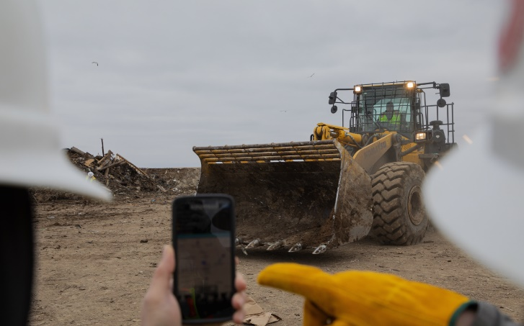Komatsu Smart Construction is a suite of digital solutions designed to optimize jobsite performance, offering waste operators powerful tools to improve efficiency, safety and decision-making in environments where margins are tight and conditions are tough. Whether managing landfill slopes, tracking compaction rates or streamlining fleet coordination at recycling and transfer facilities, Smart Construction enables more informed, data-driven operations.

From drone mapping to real-time equipment monitoring, Smart Construction helps waste operators visualize their sites, monitor material flow and identify inefficiencies that could impact capacity, compliance or cost. Its user-friendly interface, remote capabilities and compatibility with Komatsu and mixed fleets make it a practical, scalable solution for evolving landfill and waste operations.

Smart Construction solutions offer substantial benefits to waste site operators, helping to increase efficiency and productivity while lowering costs.

By bringing together machines, data and people, Smart Construction empowers waste management professionals to reduce rework, improve compliance with slope and grading specs and enhance daily planning, all while keeping operations running smoothly and safely.

**Key Smart Construction solutions and features for waste applications**

* Smart Construction Drone — create accurate topographic models for landfill planning and volume calculations
* Smart Construction Dashboard — visualize progress and material placement with cut/fill maps and 3D site views
* Smart Construction Fleet — track machine loads and cycle routes to improve fuel efficiency and reduce idle time
* Remote troubleshooting tools — monitor machine health and performance from any location, minimizing unplanned downtime
* Slope and grade tracking — ensure compliance with landfill cap and lift specifications using onboard sensors and integrated design models

**Benefits for waste site operations**

* Optimize airspace use through more precise fill management
* Reduce machine wear and fuel use with better route planning
* Improve safety by reducing guesswork in high-traffic, high-debris environments
* Enable remote site monitoring and progress reporting — ideal for multi-site operators
* Support sustainability and compliance efforts with better documentation and insight