

PC210LCE-11 excavator

*Media fact sheet*

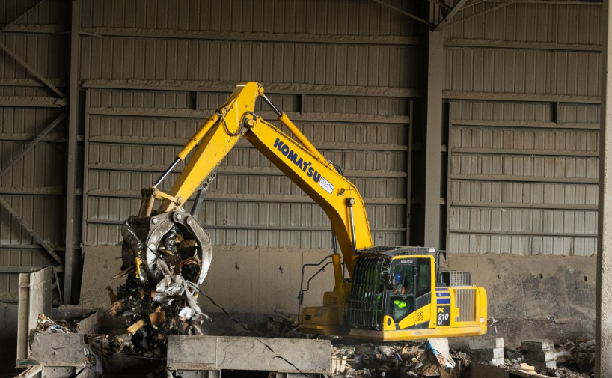The Komatsu PC210LCE-11 marks a significant milestone in the evolution of excavators, delivering all-electric performance in a proven 20-ton class machine. Ideal for waste operations that prioritize lower emissions without sacrificing productivity, the PC210LCE-11 represents Komatsu’s commitment to advancing sustainable jobsite solutions.

Equipped with a high-capacity lithium-ion battery system, the PC210LCE-11 offers zero tailpipe carbon emissions-emission operation at the point of use and significantly reduced noise levels, making it ideal for waste application, particularly indoor environments and other settings where air quality and sound restrictions are a concern. With an energy management system optimized for efficiency, the machine can typically operate through a full workday on a single charge.

The PC210LCE-11 is designed for low noise with no tailpipe emissions, the ideal combination of features for indoor waste operations and landfills in populated areas. Note: image above features the PC210LC; intended for illustration purposes only.

Built on Komatsu’s trusted excavator platform, the PC210LCE-11 retains the familiar feel and control layout that operators expect, while integrating smart technologies such as Komtrax telematics for real-time fleet monitoring and performance insights. With fewer moving parts and no diesel engine, the PC210LCE-11 also reduces routine maintenance needs, lowering total operating costs over time.

**Quick specs**

* Motor power:165 HP @ 2,000 min-1 (123 kW)
* Operating weight: 51,397 - 53,882 lbs (23,313 - 24,440kg)
* Bucket capacity: 0.65 – 1.22 m3 (0.50 - 0.93 m³)

**Quick benefits**

* Helps reduce total operating costs through simplified maintenance
* Quiet operation and zero tailpipe emissions — ideal for work in indoor waste facilities and noise-sensitive areas
* Contributes to carbon reduction goals without compromising job site productivity