FH45-2 forklift

*Media fact sheet*

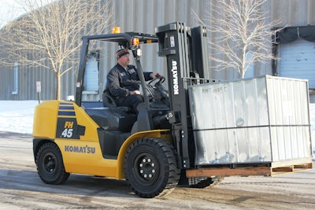The Komatsu FH45-2 forklift is a heavy-duty, 9,000 lb-class hydrostatic-drive lift truck engineered for the high-demand conditions of waste and recycling operations. From transfer stations to material recovery facilities, the FH45-2 delivers reliable performance, exceptional durability, and precise control, even in harsh, debris-filled environments.

At the heart of the FH45-2 is its hydrostatic drive system (HST), offering smooth, intuitive control and responsive handling—ideal for tight turns and frequent directional changes common in waste sites. With fewer moving parts than conventional torque converter systems, HST helps reduce maintenance costs and increase uptime.

*The FH45-2 is designed for the kind of heavy-duty material handling that is typical with many waste applications while offering operators responsive handling and intuitive controls.*

Designed for productivity in dirty, uneven conditions, the FH45-2 features a sealed, heavy-duty frame, an enclosed wet disc brake system, and optional full cab configurations for operator protection. Combined with low fuel consumption and reduced wear on components, this forklift is built for productivity, even in challenging waste applications.

**Quick specs**

Capacity: 9,000 lbs. (4,082 kg)

Load center: 24 in (600 mm)

Standard lift height: 130 in (3,300 mm)

**Quick benefits**

* Reduced fuel consumption while reducing particulate exhaust by 90%
* Fuel consumption is reduced by almost 30% in heavy-duty cycle operations*
* Innovative hydrostatic transmission provides excellent controllability with maximized efficiency
* Spacious cab, ergonomic controls and low vibration help reduce fatigue during long shifts

*\*Compared to the same class and capacity torque converter machine*