**WA485-11 and WA485-11YL wheel loader**

*Media fact sheet*

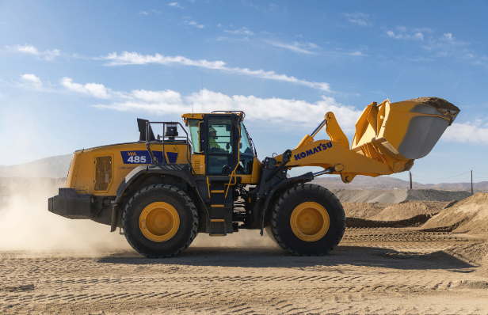The Komatsu WA485-11 is a new wheel loader with advanced features designed to enhance productivity, help control fuel consumption, and make maintenance easier (when compared to the previous model). With a newly developed, fuel-efficient Komatsu DBA127 engine, a Komatsu Hydraulic Mechanical Transmission (KHMT) engineered to deliver excellent controllability and high transmission efficiency, and a new cab with operator-assistance features like Angle Feedback Joystick Steering (AFJS) controls, it’s designed to be an ideal wheel loader for aggregate operations.

The WA485-11YL features a purpose-built configuration that addresses the unique challenges of applications.

The new WA485-11YL adds a yard loader package with unique features engineered for aggregate jobs and moving material with efficiency. Compared to the WA485-11 standard base model, it has a larger-capacity bucket, an additional counterweight and wide tires for enhanced stability. This makes this purpose-built wheel loader a great choice for handling, stockpiling and loading processed material onto commercial trucks with three passes.

The addition of the proprietary Komatsu Hydraulic Mechanical Transmission to the WA485-11 is notable, giving this workhorse an advanced design engineered to enhance productivity and efficiency of material loading cycles. Plus, the KHMT's control system comprehensively assesses the work situation and works to control power distribution, synchronizing low fuel consumption at low engine speed and delivering exceptional acceleration performance.

**Quick specs: WA485-11**

* Horsepower: 362 HP (270 kW) @ 1,600 rpm
* Operating weight: 61,432 - 64,997 lbs. (27,865 - 28,575 Kg)
* Bucket capacity 6.4-7.2 yd³ (4.9-5.5 m³)

**Quick benefits WA485-11**

* 12% lower fuel consumption*
* 21% more engine power*
* 13% greater climbing speed (on a 6° slope)*
* 21% average reduction in maintenance costs due to extended intervals for hydraulic and oil filter changes, as well as lengthening the time needed between KDPF cleanings*

*Compared to WA480-8