

Montabert V32 hydraulic breaker
Media fact sheet
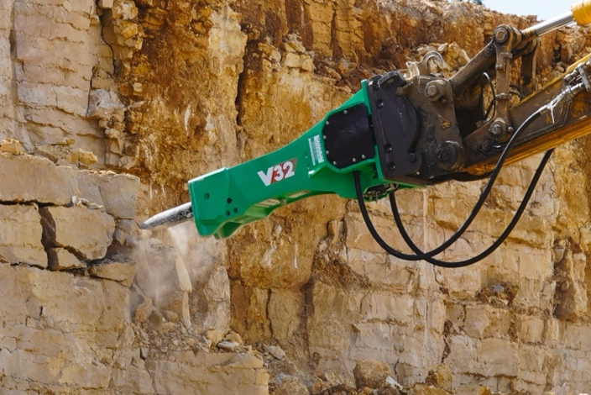
The Montabert V32 breaker adjusts impact energy and striking rate based on material hardness.
The Montabert V32 hydraulic breaker is a high-performance tool designed for demanding applications such as demolition, excavation and quarrying. Its innovative automatic speed variation system enables the breaker to adjust impact energy and striking rate based on material hardness, enhancing efficiency and productivity. The V32’s advanced features, including an energy recovery system and blank-firing protection, help ensure reliable operation while reducing wear and tear on the breaker and carrier.

This breaker enhances operator safety and convenience with its fully enclosed cradle that minimizes noise and protects against debris. The patented tool protection system helps extend the lifespan of wear parts, while the automatic lubrication system reduces maintenance needs. Designed for use with excavators in the 18–30 metric ton (39,700–66,150 lbs.) range, the V32 is a versatile solution for heavy-duty tasks.

Key features
- Automatic speed variation system for optimized performance
- Energy recovery system to reduce oil flow requirements
- Blank-firing protection to prevent unnecessary wear
- Fully enclosed cradle for noise reduction and debris protection
- Patented tool protection system for extended tool life

Quick specs
Carrier weight range: 18-30 metric tons (39,700-66,150 lbs.)
Operating weight – breaker only: 1,217 kg (2,683 lbs.)
Frequency: 285-1,050 bpm

