

Montabert HCP 850/1000 pulverizer
Media fact sheet

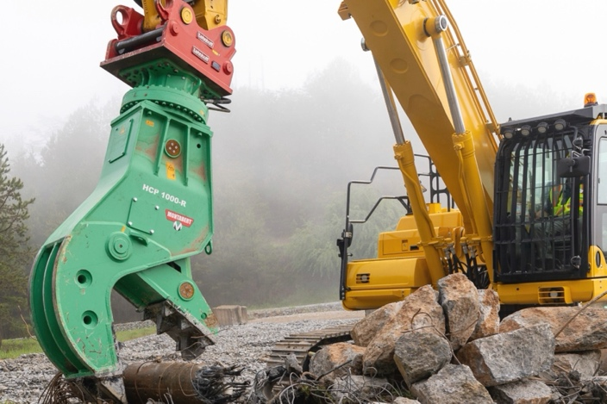
Montabert HCP 850/1000 hydraulic pulverizers are designed for demanding demolition, recycling, and steel bar clearing applications. These tools enable efficient crushing and separation of materials on-site, reducing waste and enhancing productivity.

The HCP series features heavy-duty construction with high-strength steel, making it ideal for handling tough materials while maintaining durability over time. Its integrated speed valve helps ensure faster cycle times, improving operational efficiency.
The Montabert HCP 850 and HCP 1000 pulverizers are designed for demanding demolition and recycling applications.

These pulverizers are compatible with carriers in the 33,000-88,000 lb. (15-40 metric ton) range, providing flexibility across various job sites.

Key features
- Integrated speed valve for faster cycle times
- Heavy-duty steel construction for enhanced durability
- Reversible and exchangeable wear parts for easy maintenance
- 360° rotation on R models for accurate positioning
- High closing force for efficient material crushing

Quick specs
Carrier weight range: 33,070-88,185 lbs. (15-40 metric tons)
Maximum jaw opening: 39.3 in (1,000 mm) for HCP 1000 and 1000-R
Maximum jaw opening: 34.2 in (870 mm) for HCP 850 and 850-R
Operating weight – pulverizer only: 5,203 lbs. (2,360 kg) for HCP 1000; 6,107 lbs. (2,770 kg) for HCP 1000-R
Operating weight – pulverizer only: 3,682 lbs. (1,670 kg) for HCP 850; 4,376 lbs. (1,985 kg) for HCP 850-R

