

HM400-5 articulated truck

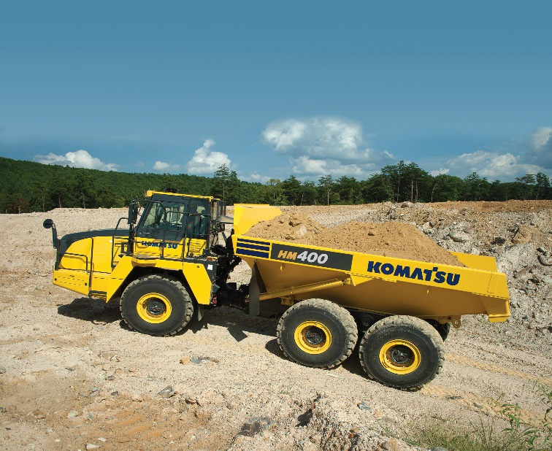*Media fact sheet*

The HM400-5 articulated truck is engineered for operators of all experience levels to move material across challenging and adverse terrain.

For jobsites where roads are not well-established, or may not exist, Komatsu's HM400-5 articulated truck is engineered to move material across challenging and adverse terrain by delivering productive, consistent performance — for operators of all experience levels.

The Komatsu Traction Control System (KTCS) on the HM400-5 offers exceptional performance in poor underfoot conditions. The traction system requires no operator input and functions automatically by monitoring and adjusting to changing conditions, without sacrificing steering performance.

A standard payload meter system ensures optimal loading and production. The loaded material weight can be viewed in the cab on a monitor, from the loading tool via cab-mounted external display lamps, or through Komtrax, the company’s telematics technology. External lamps on the truck illuminate green, yellow or red as the payload increases to help prevent under and overloaded haul cycles.

**Quick specs**

* Net horsepower: 466 @ 2000 rpm
* Empty vehicle weight: 77,283 lbs.
* Capacity: 44.1 st

**Quick benefits**

* Excellent maneuverability
* Automated powertrain features
* Customer-approved ride comfort
* Designed for durability